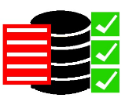

SQL Server

Evaluation Report

Created By: SQL Evaluator Team

Date: September 17, 2016